**Chapter 7**

**Second-Order Differential Equations**

**7.1 Second-Order Linear Equations**

**Section Exercises**

**Classify each of the following equations as linear or nonlinear. If the equation is linear, determine whether it is homogeneous or nonhomogeneous.**

1. 

Answer: linear, homogenous

3. 

Answer: nonlinear

5. 

Answer: linear, homogeneous

**For each of the following problems, verify that the given function is a solution to the differential equation. Use a graphing utility to graph the particular solutions for several values of *c*1 and *c*2. What do the solutions have in common?**

7. **[T]**

Answer: This is a proof; therefore, no answer is provided.

9. **[T]**

Answer: This is a proof; therefore, no answer is provided.

**Find the general solution to the linear differential equation.**

11. 

Answer: 

13. 

Answer: 

15. 

Answer: 

17. 

Answer: 

19. 

Answer: 

21. 

Answer: 

23. 

Answer: 

25. 

Answer: 

27. 

Answer: 

29. 

Answer: 

**Solve the initial-value problem.**

31. 

Answer: 

33. 

Answer: 

35. 

Answer: 

37. 

Answer: 

**Solve the boundary-value problem, if possible.**

39. 

Answer: 

41. 

Answer: No solutions exist.

43. 

Answer: 

45. 

Answer: 

47. Find a differential equation with a general solution that is 

Answer: 

**For each of the following differential equations:**

1. **Solve the initial value problem.**
2. **[T]Use a graphing utility to graph the particular solution.**

49. 

Answer: a. b.

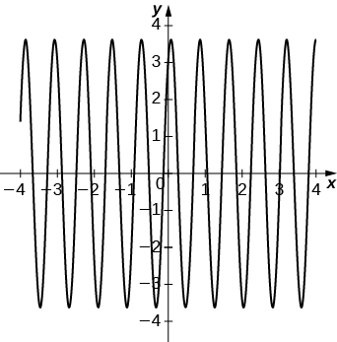

51. 

Answer: a. b.

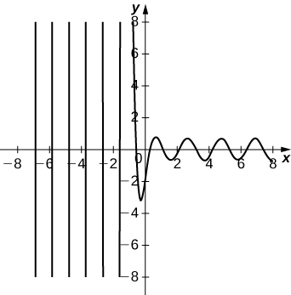

53. Prove that if *a, b,* and *c*are positive constants, then all solutions to the second-order linear differential equation  approach zero as  (*Hint:* Consider three cases: two distinct roots, repeated real roots, and complex conjugate roots.)

Answer: This is a proof; therefore, no answer is provided.

This file is copyright 2016, Rice University. All Rights Reserved.